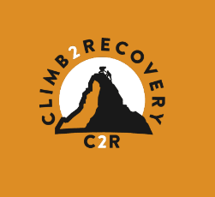
Key Info
- Trek through the High Atlas Mountains and complete a 6-day circuit
- Culminating with the summit of North Africa’s highest mountain – Toubkal, at (4167m)
- Camping alongside the support team of local guides and mules
- Trek, reflect and take in the Atlas Mountain landscape
- Transfer in/out of Marrakesh from UK/Ireland
MOROCCO – High Atlas Circuit 2024
CLIMB2RECOVERY

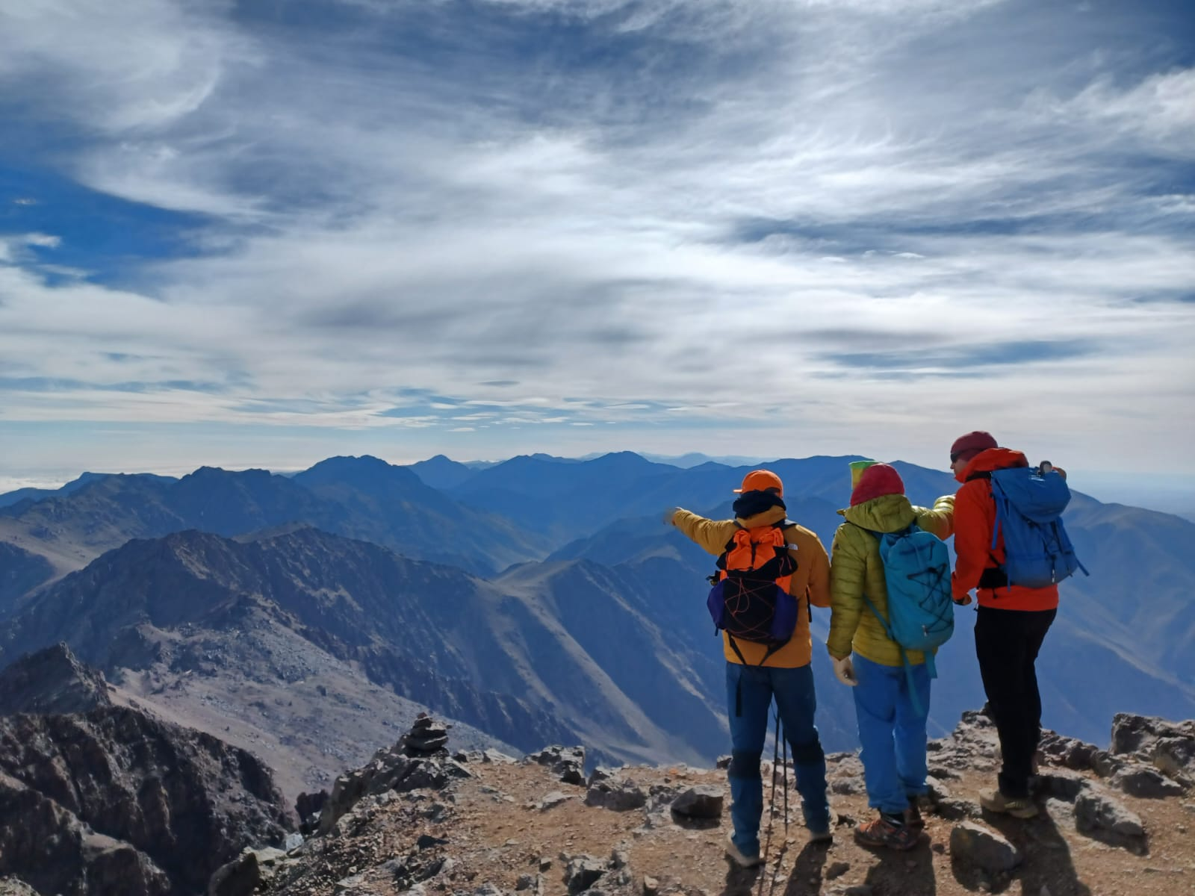
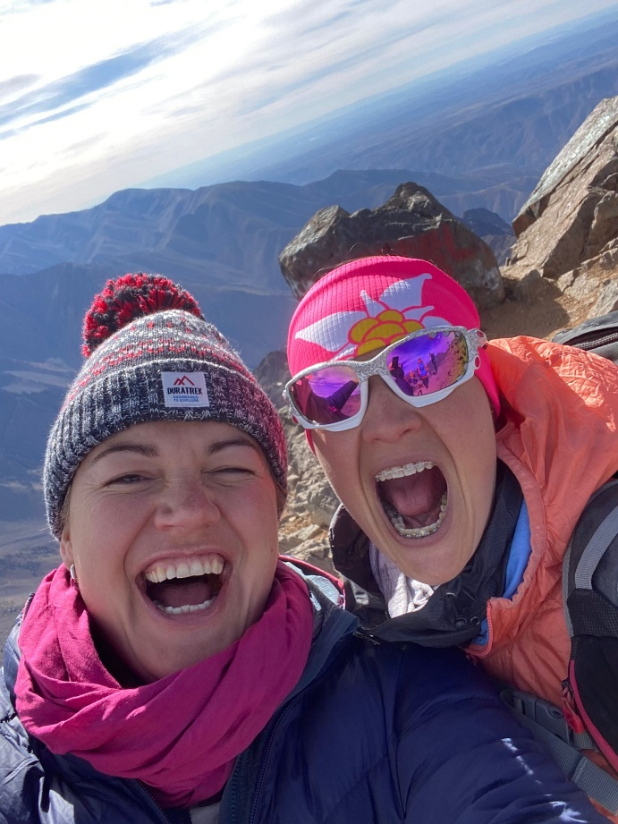
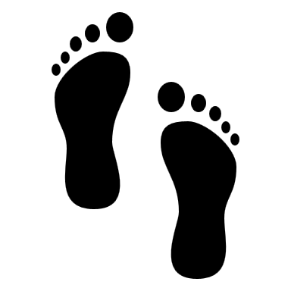
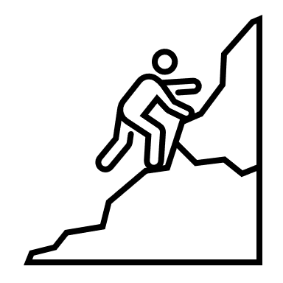
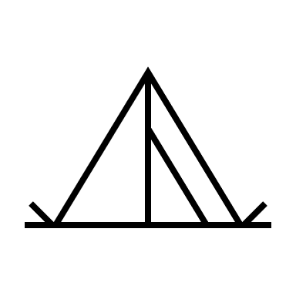
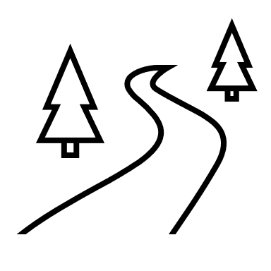
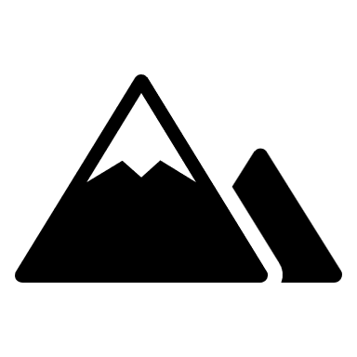
Max group size
10 pax

6 Days Trekking + transfer day and cultural visit

Challenging trek and mountain phase
Fully supported &
Guided Trek

Camping
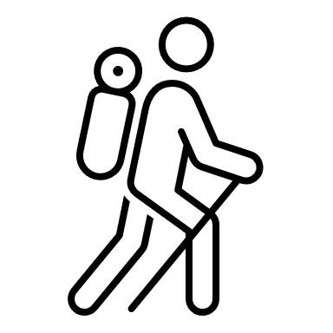
W| www.jonniemiller.co.uk M| +33 (0)7 86 15 05 75 E| jonnie@c2r.org

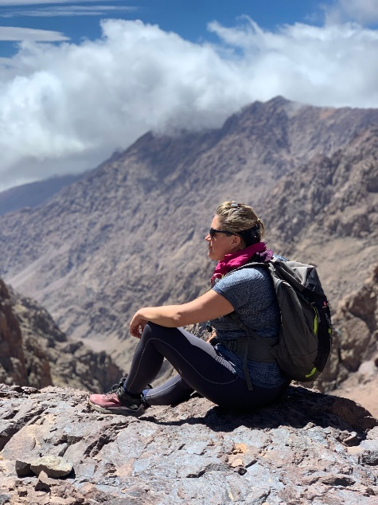
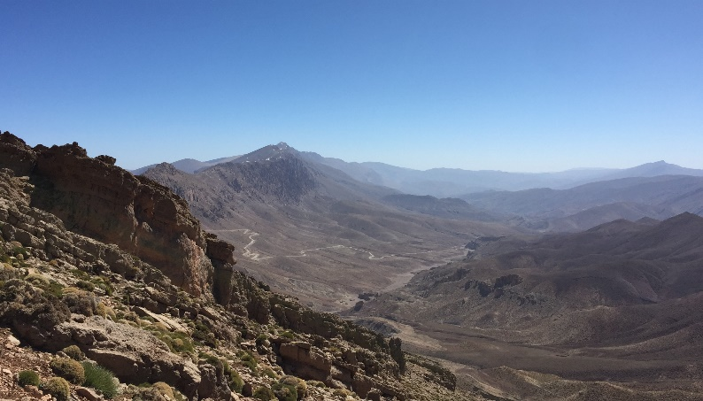
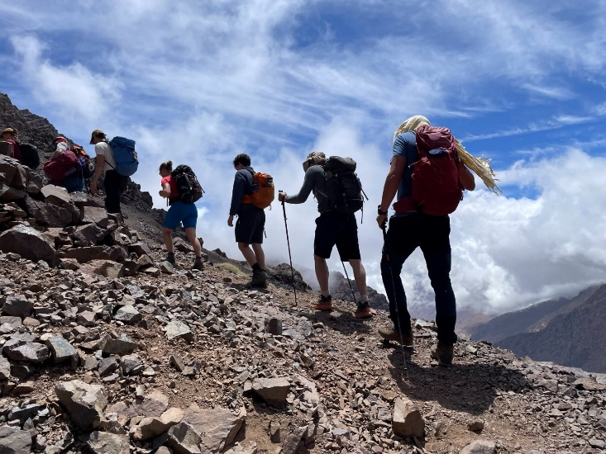
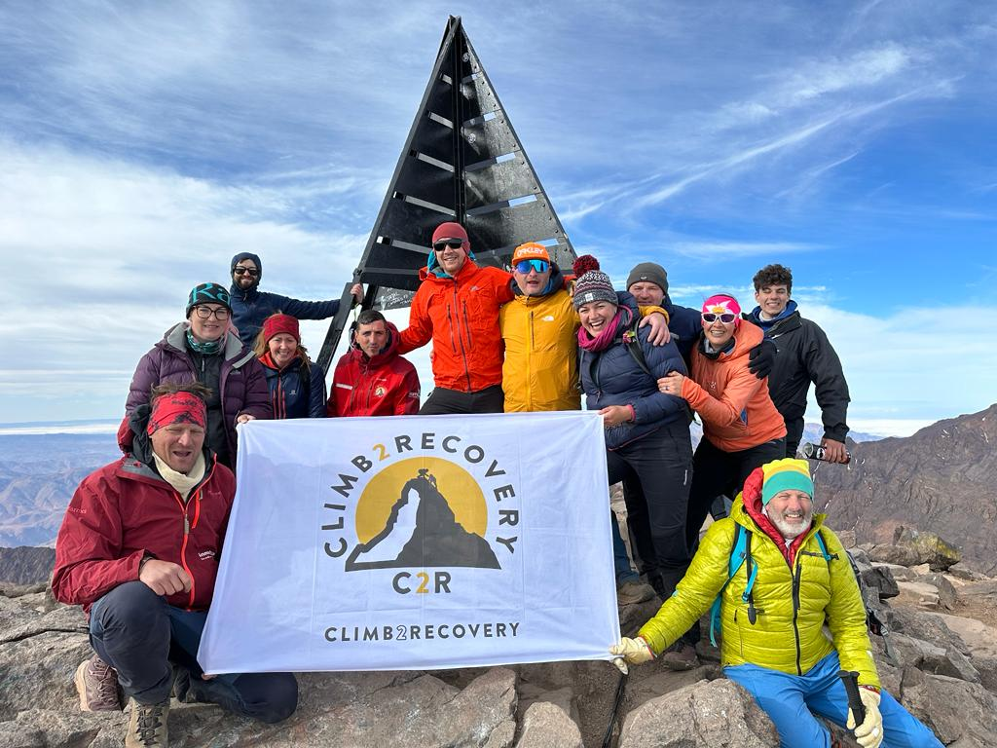
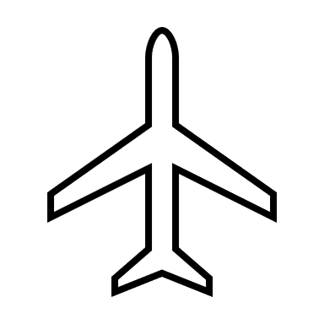
Flights
Various departures from UK
(LGW/BRS/LHR/STN/MAN) – Marrakesh (RAK)

Insurance
Cover required with BMC insurance policy

Pricing
£100.00 personal contribution (£100 in full)

Transfers
Private Minibus or people carrier
To and from Airport / Hotel / Mountain Village / Hotel / Airport
RAK-Marrakesh 15mins / Marrakesh – Imlil 1hr30mins (minibus)

When?
25th May - 2nd June ***Flight dependent***
Who is this for?
C2R Members and Supporters!
This is a challenging multi-day trek over 6-days, a good level of physical fitness is required.

It will appeal to those wishing to visit and immerse themselves in Moroccan culture, experiencing trekking in the Atlas, whilst climbing North Africa’s highest mountain.

Though the days are relatively short in distance, they do often have a lot of height gain and loss, as is the territory of the mountains and especially that of the Atlas range.

What is included?
- Transfers
- Food, water, soft drinks
- Trekking Leaders and Local Guides
- In-country support, mules, accommodation, tents, and camping matt
- All meals whilst in country on the itinerary

What is excluded?
- Personal vaccinations
- Sleeping bag and personal clothing
- Airport meals
- Tipping cost (£30pp)
- Personal sundries
- Mini-bar and shopping!

Introduction

This multi-day trek through the High Atlas Mountains travels around Mt Toubkal, it is a real trekkers gem in the heart of the Toubkal massif.

The journey starts from Imlil (1700m), a high mountain village - the gateway to the region and jokingly called the ‘Chamonix of Morocco’.

The route enables us to acclimatise well to the altitude as it travels over many mountain passes, and remote villages which are off well-trodden paths. Offering the opportunity to meet local Berber people and perhaps even share a mint tea.

W| www.jonniemiller.co.uk M| +33 (0)7 86 15 05 75 E| jonnie@c2r.org

MOROCCO – High Atlas Circuit 2024
 | Detail | Accommodation | Meals
Day 1 | Flights and Transfer to Marrakesh | Riad in Marrakesh | Marrakesh
Day 2 | Breakfast at Riad and Transfer to Imlil – Lunch – Trek to Tachddirt | Camping in Tachddirt | Camp meal
Day 3 | Trek Tachddirt to Azib Likemt | Camping in Azib Likemt | Camp meal
Day 4 | Trek Azib Likemt – Amsouzart | Tea house in Amsouzart | Camp meal and at Teahouse
Day 5 | Trek Amsouzart – Lac d’Ifni | Camping beside lake | Camp meal
Day 6 | Trek Lac d’Ifni – Toubkal Refuge | Camping at Refuge ‘Base Camp’ | Camp meal
Day 7 | Trek to summit Toubkal – Imlil | Riad in Imlil or Marrakesh | Riad or Local restaurant
Day 8 | Transfer / cultural / rest / travel | Riad in Marrakesh or Return travel  **Flight depending** | Local restaurant

MOROCCO – High Atlas Circuit 2024
Medical Plan | Actions
Minor | Self-administer or treatment given by trekking leader or suitably qualified member of the group
Medium | Treatment by trekking leader and assisted by local guides or suitable persons as required. Decision made by trek leader to next action to be taken. Assess and continue/adapt plan as necessary.
Major | 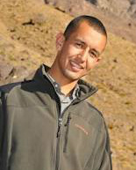  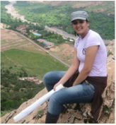  Treat and seek emergency assistance. Local guide to facilitate emergency call and identify HLS or nearest road head for evacuation as required.
In-country support
The local provider and in-country support whilst in Morocco will be fulfilled by Mountain Travel Morocco (MTM) who will support the route with a team of guides and muleteers, together with cooks and logistics support. Office in Imlil.
Mountain guides in the high Atlas Mountains (mountain-travel-morocco.com)

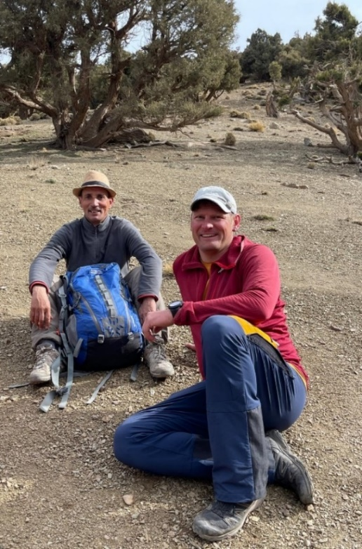
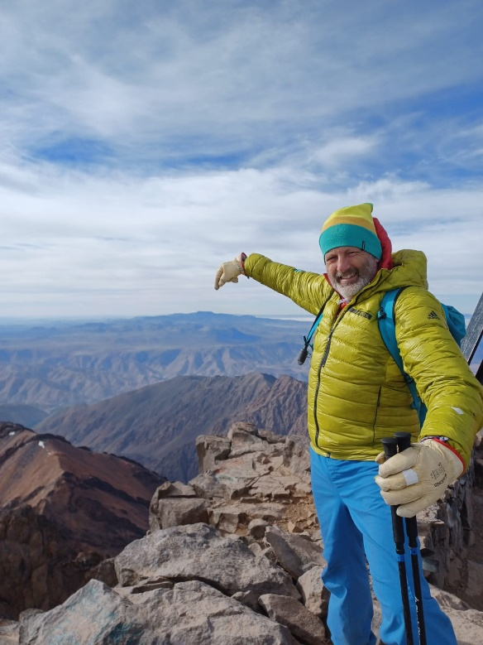
W| www.jonniemiller.co.uk M| +33 (0)7 86 15 05 75 E| jonnie@c2r.org

W| www.jonniemiller.co.uk M| +33 (0)7 86 15 05 75 E| jonniemiller1385@hotmail.com

W| www.jonniemiller.co.uk M| +33 (0)7 86 15 05 75 E| jonniemiller1385@hotmail.com

